STATISTICAL ANALYSIS PLAN
Protocol N° JP-2266-101-FIH / OP109219.JEI
Draft 2 - December 1st, 2020

A Dose-randomized, Double-blind, Placebo-controlled, Single- and Multiple-dose, Dose-escalation, Phase I Clinical Trial to Investigate the Safety, Tolerability, and Pharmacokinetic and Pharmacodynamic Characteristics of JP-2266 after Oral Administration in Healthy Male Caucasian Subjects

SPONSOR
JEIL Pharmaceutical Co., Ltd.
343, Sapyeong-daero
Seocho-gu, Seoul
Republic of Korea
AUTHOR
Laure-Anne GIANNONE
EUROFINS OPTIMED
1, rue des Essarts
38610 Gières
France

« This document is the property of the Sponsor and may not – in full or in part – be passed on, reproduced, published or used by authorities or other applicants for approval or registration purposes without the express permission of the Sponsor. »

SIGNATURES
Protocol N°: JP-2266-101-FIH / OP109219.JEI
Title : A Dose-randomized, Double-blind, Placebo-controlled, Single- and Multiple-dose, Dose-escalation, Phase I Clinical Trial to Investigate the Safety, Tolerability, and Pharmacokinetic and Pharmacodynamic Characteristics of JP-2266 after Oral Administration in Healthy Male Caucasian Subjects

DATE SIGNATURE
Sponsor:

JEIL Pharmaceutical Co., Ltd.
343, Sapyeong-daero
Seocho-gu, Seoul
Republic of Korea

Represented by:

Suk-Je Sung
343, Sapyeong-daero
Seocho-gu, Seoul
Republic of Korea

Statistician:

Laure-Anne Giannone
EUROFINS OPTIMED
Biometry Department
1, rue des Essarts
38610 Gières
France

TABLE OF CONTENTS
1 INTRODUCTION 8
1.1 Study design 8
1.2 Objectives of the study 9
1.2.1 Primary objectives 9
1.2.2 Secondary objectives 9
1.2.3 Exploratory objectives 9
1.3 Analysis endpoints 9
1.3.1 Primary endpoints 9
1.3.2 Secondary endpoints 10
1.3.3 Exploratory endpoints 11
1.4 Study schedule 11
2 STUDY POPULATIONS AND TREATMENTS 22
2.1 Randomized subjects 22
2.2 Sample size 22
2.3 Definition of analysed populations 22
2.4 Investigational treatment 22
3 STATISTICAL ELEMENTS 24
3.1 General information 24
3.2 Statistical methods scheduled in the protocol 25
3.3 Imputation method 25
3.4 Descriptive statistics 25
3.5 Inferential statistics 25
4 STATISTICAL ANALYSES 26
4.1 Status of subjects 26
4.2 Baseline characteristics 26
4.3 PD evaluation 28
4.4 PK/PD evaluation 29
4.5 Safety 30
4.5.1 Adverse events 30
4.5.2 Laboratory 31
4.5.3 Urinalysis 33
4.5.4 Additional urine tests 34
4.5.5 Clinical criteria 35
4.6 Exploratory analysis 37
4.7 Study conduct 38
5 INDIVIDUAL DATA 39
6 APPENDIX: Normal Ranges 47

LIST OF TABLES

Table 1 – Study flow chart for Part A – SAD 12
Table 2 – Detailed flow chart for Part A – SAD 13
Table 3 – Study flow chart for Part A – Food effect cohort 14
Table 4 – Detailed flow chart for Part A – Food effect cohort 15
Table 5 – Study flow chart for Part B – MAD 16
Table 6 – Detailed flow chart for Part B – MAD (1/4) 18
Table 7 – Detailed flow chart for Part B – MAD (2/4) 19
Table 8 – Detailed flow chart for Part B – MAD (3/4) 20
Table 9 – Detailed flow chart for Part B – MAD (4/4) 21

DOCUMENT HISTORY

Version | Effective date | Reason for change
Draft 1 | October 26, 2020 | Document creation
Draft 2 | December 1st, 2020 | Integration of Eurofins Optimed comments after internal review

LIST OF ABBREVIATIONS

AE | Adverse event
Ae | Amount excreted
Ae_{0-24h} | Cumulative amount of drug excreted unchanged in urine between 0 and 24 hours
Ae_{last} | Amount of drug excreted unchanged in urine between 0 and the last time of collection
ALT | Alanine leucine transferase
a.m. | Ante meridiem
aPTT | Activated partial thromboplastin time
AST | Alanine serine transferase
AUC_{0-24h} | Area under the plasma concentration curve from administration up to the last quantifiable concentration at time 24h
%AUC_{extra} | Percentage of extrapolated AUC_{inf}
AUC_{inf} | Area under the plasma concentration-time curve from administration up to infinity with extrapolation of the terminal phase
AUC_{last} | Area under the plasma concentration curve from administration up to the last quantifiable concentration at time t
AUEC | Area under the effect curve
BMI | Body mass index
bpm | beats per minute
BUN | Blood urea nitrogen
Cl/F | Clearance
Cl_{r} | Renal clearance
C_{max} | Observed maximum plasma concentration
C_{min} | Observed minimum plasma concentration
CPK | Creatine phosphokinase
CS | Clinically significant
D | Day
ECG | Electrocardiogram
eCRF | Electronic Case Report Form
e.g. | exempli gratia
E_{max} | Maximum response
%fe | Fraction of the dose excreted in urine
GGT | Gamma Glutamy1 Transferase
h | Hour(s)
HbA1c | Haemoglobin A1c
HBsAg | Hepatitis B surface antigen
HCV | Hepatitis C virus
HIV | Human immunodeficiency virus
HR | Heart rate
i.e. | id est
INR | International normalized ratio
ITTS | Intent-to-treat set
K_{el} | Elimination rate constant
LDH | Lactate dehydrogenase
LLN | Lower limit of normal
MAD | Multiple administration dose
Max | Maximum
MCH | Mean corpuscular haemoglobin
MCHC | Mean corpuscular haemoglobin concentration
MCV | Mean corpuscular volume
MedDRA | Medical dictionary for Regulatory Activities
mg | Miligram
Min | Minimum
mL | Mililitre
n | Number of observations
N | Number of subjects
NA | Not applicable
NCS | Not clinically significant
NTEAE | Non-treatment emergent adverse event
OGTT | Oral glucose tolerance test
PD | Pharmacodynamics
PDS | Pharmacodynamic set
PK | Pharmacokinetics
PKS | Pharmacokinetic set
SAD | Single administration dose
SAE | Serious adverse event
SBP | Systolic blood pressure
SD | Standard deviation
SEM | Standard error of the mean
SS | Safety set
T | Time
t_{1/2} | Plasma elimination half-life
TEAE | Treatment emergent adverse event
t_{max} | First time to reach C_{max}
µg | Microgram
UGE | Urine glucose excretion
ULN | Upper limit of normal
Vd/F | Volume of distribution
WHO-DD | World health organization - Drug dictionary

INTRODUCTION
In accordance with the main characteristics of the protocol, the Statistical analysis plan (SAP) details the scheduled analyses that have to be performed in order to investigate the safety, tolerability and pharmacodynamics characteristics of JP-2266 after oral administration in healthy male Caucasian subjects.

Study design
The study will be divided in 2 successive parts:
- Study Part A will be a single ascending dose (SAD) study in healthy male Caucasian volunteers to assess the safety, the tolerability, the pharmacokinetics and the pharmacodynamics of JP-2266 with nested one way cross-over for food effect. All subjects will receive a placebo administration on D-1 in order to determine the placebo effects of the inert material intake (performed in -blind condition) followed by a single administration period of either JP-2266 or placebo on D1. Five JP-2266 doses will be studied.
One cohort of the SAD study part (dose 80 mg) will be used to assess the safety, the tolerability, the pharmacokinetics and the pharmacodynamics of JP-2266 in fast or fed conditions.
Each subject will participate in one treatment period only (fasted), with the exception of subjects of the food effect group who will participate in two treatment periods (fasted/fed), with a washout phase of at least 14 days between the two treatment periods.
- Study Part B will be a multiple ascending dose (MAD) study in healthy male Caucasian volunteers to assess the safety, the tolerability, the pharmacokinetics parameters and the pharmacodynamics of JP-2266. In order to determine the placebo effects of the inert material intake each subject will first receive on D-1 a JP-2266 placebo administration (performed in blind condition for the subject) followed by a 15-day repeated administration period of either JP-2266 or placebo (from D1 to D15 included). Three JP-2266 dose levels will be studied.
To minimize the risk, the administration of the investigational product in each dose group of the study will be done sequentially within each cohort (parts A and B). In each dose level, the two first subjects will be randomized as one verum and one placebo. The decision to proceed with the administration of the 6 remaining subjects will be taken by the investigator on the basis of clinical and biological safety data after 48 hours for Part A and 3 days for Part B. Before each dose escalation, the Study Safety Committee, consisting of an investigator, a clinical pharmacologist, sponsor representatives and a person responsible of pharmacokinetics analysis, will evaluate the safety and PK data of the cohort(s) already performed and will give an approval for the next dose.
Up to seventy subjects are planned to be enrolled:
- Part A/SAD: 5 groups of 8 subjects (6 active/2 placebo), for a total of 40 subjects;
- Part A/Food effect: will be tested in period 2 for 1 group of the SAD part (dose 80 mg) of 8 subjects (6 active/2 placebo);
- Part B/MAD: 3 groups of 10 subjects (8 active/2 placebo), for a total of 30 subjects.

Objectives of the study

Primary objectives
The main objectives of this study will be:
Part A – SAD
To evaluate the safety and tolerability of JP-2266 after single oral administration at 5 different doses in healthy male Caucasian subjects.
Part A – Food effect cohort
To evaluate the impact of food intake on pharmacokinetics after an oral administration of JP-2266 in healthy male Caucasian subjects in fast or fed conditions.

Part B – MAD
To evaluate the safety and tolerability of JP-2266 after multiple oral administration at 3 different doses in healthy male Caucasian subjects.

Secondary objectives
The secondary objectives of this study will be:
Part A – SAD
- To evaluate the pharmacokinetics parameters of JP-2266 after single oral administration at 5 different doses in healthy male Caucasian subjects;
- To evaluate the pharmacodynamics parameters of JP-2266 after single oral administration at 5 different doses in healthy male Caucasian subjects.
Part A – Food effect cohort
- To evaluate the safety and tolerability of JP-2266 after single oral administration in fast or fed conditions in healthy male Caucasian subjects;
- To evaluate the impact of food on pharmacodynamics after an oral administration of JP-2266 in healthy male Caucasian subjects in fast or fed conditions.
Part B – MAD
- To evaluate the pharmacokinetics parameters of JP-2266 after multiple oral administration at 3 different doses in healthy male Caucasian subjects.
- To evaluate the pharmacodynamics parameters of JP-2266 after multiple oral administration at 3 different doses in healthy male Caucasian subjects.

Exploratory objectives
The exploratory objectives of this study for both parts will be:
- To identify JP-2266 metabolites in human blood and urine after JP-2266 oral administration;
- To identify genes involved in JP-2266 absorption and metabolism.

Analysis endpoints

Primary endpoints
The primary endpoints will be:
Part A – SAD
Assessment of systemic tolerability and safety:
- Adverse events
- Vital signs
- Physical examination
- ECG
- Biological analysis:
  - Blood: Haematology, Coagulation, Biochemistry
  - Urine: urinalysis, urine electrolyte test
Part A – Food effect cohort
Pharmacokinetic assessments of JP-2266:
- In Plasma: C_{max}, t_{max}, C_{min}, AUC_{0-24h}, AUC_{last}, AUC_{inf}, %AUC_{extra}, t_{1/2}, K_{el}, Vd/F, Cl/F
- In Urine: CL_{r}, Ae_{last}, Ae_{0-24h}, %fe.
The analysis of C_{max}, AUC_{last} and AUC_{inf} will be performed on the log-transformed values using a mixed model analysis of variance (ANOVA) to determine the geometric mean ratio between fed and fasted conditions and its 90% Confidence Interval (CI).
Part B – MAD
Assessment of systemic tolerability and safety:
- Adverse events
- Vital signs
- Physical examination
- ECG
- Biological analysis:
  - Blood: Haematology, Coagulation, Biochemistry
  - Urine: urinalysis, urine electrolyte test, β2-microglobulin, 24-hour urine creatinine level

Secondary endpoints
The secondary endpoints will be:
Part A – SAD
- Pharmacokinetic assessments of JP-2266:
  - In Plasma: C_{max}, C_{min}, t_{max}, AUC_{0-24h}, AUC_{last}, AUC_{inf}, %AUC_{extra}, t_{1/2}, K_{el}, Vd/F, Cl/F
  - In Urine: CL_{r}, Ae_{last}, Ae_{0-24h}, %fe.
- Pharmacodynamics assessments of JP-2266 effect:
  - In Plasma: Plasma glucose (AUEC, E_{max}, ΔE_{max}),
  - In Urine: urine glucose excretion (Ae, cumulative at each time point).
Part A – Food effect cohort
- Assessment of systemic tolerability and safety:
  - Adverse events
  - Vital signs
  - Physical examination
  - ECG
  - Biological analysis:
    - Blood: Hematology, Coagulation, Biochemistry
    - Urine: urinalysis, urine electrolyte test
- Pharmacodynamics assessments of JP-2266 effect:
  - In Plasma: Plasma glucose (AUEC, E_{max}, ΔE_{max}),
  - In Urine: urine glucose excretion (Ae, cumulative at each time point).
Part B – MAD
- Pharmacokinetic assessments of JP-2266 at Day 1 and at Steady State:
  - In Plasma: C_{max}, C_{min}, t_{max}, AUC_{0-24h}, AUC_{last}, AUC_{inf}, %AUC_{extra}, t_{1/2}, K_{el}, Vd/F, Cl/F
  - In Urine: CLr, Ae_{last}, Ae_{0-24h}, %fe.
- Pharmacodynamics assessments of JP-2266 effect:
  - In Plasma: Oral Glucose Tolerance Test (OGTT) (AUEC, E_{max}, ΔE_{max}), Plasma glucose (AUEC, E_{max}, ΔE_{max}), Insulin (AUEC, E_{max}), Body Weight, HbA1c (change from baseline);
  - In Urine: urine glucose excretion (Ae, cumulative at each time point).

Exploratory endpoints
The exploratory endpoints for all study parts will be:
- To determine factors that may affect the safety, pharmacokinetics, and pharmacodynamics, an exploratory analysis of drug metabolites can be performed using samples collected for the pharmacokinetic evaluation of investigational products. If relevant drug metabolites are detected, the correlation between pharmacokinetic parameters, including metabolite-to-parent drug exposure ratios, and pharmacokinetics/pharmacodynamics can be evaluated.
- If inter-individual pharmacokinetics results differences are observed, genotyping analysis could be performed to assess the correlation between genetic polymorphism and pharmacokinetic parameters.

Study schedule
The subjects will perform examinations detailed in the following study flow charts:

Table 1 – Study flow chart for Part A – SAD
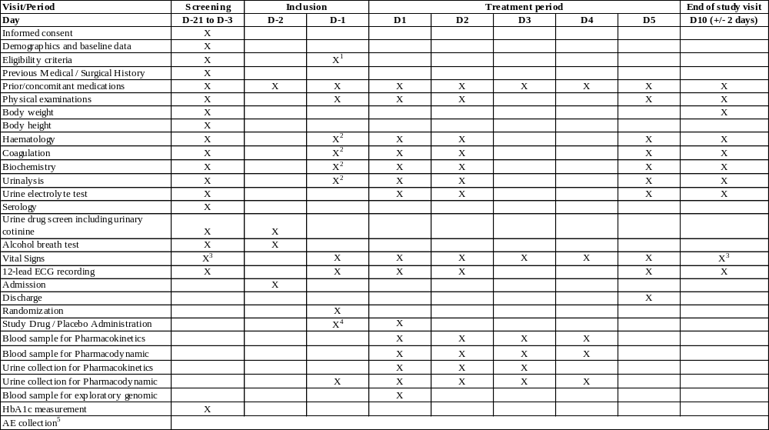
¹ Confirmation of the Inclusion/exclusion criteria prior to randomization number assignment and prior to first study product administration;
² At Pre-dose;
³ Including body temperature;
⁴ Placebo administration in blind condition for the subject;
⁵ All AEs will be reported.
Table 2 – Detailed flow chart for Part A – SAD
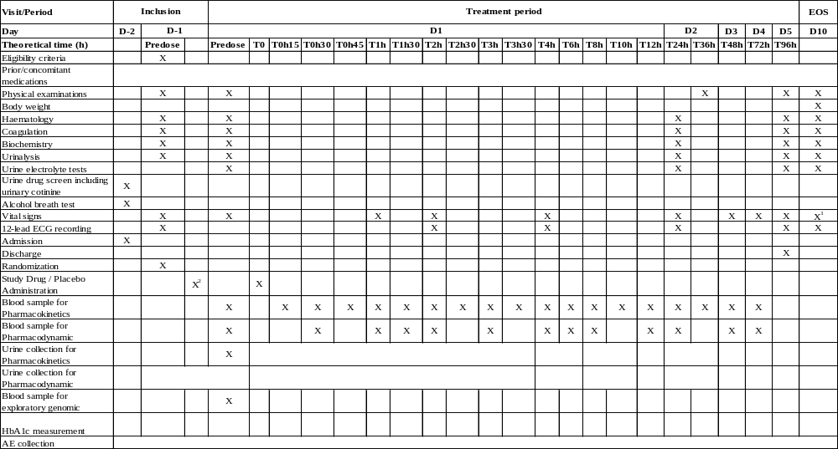
¹ Including body temperature;
² Placebo administration in blind condition for the subject.
Table 3 – Study flow chart for Part A – Food effect cohort
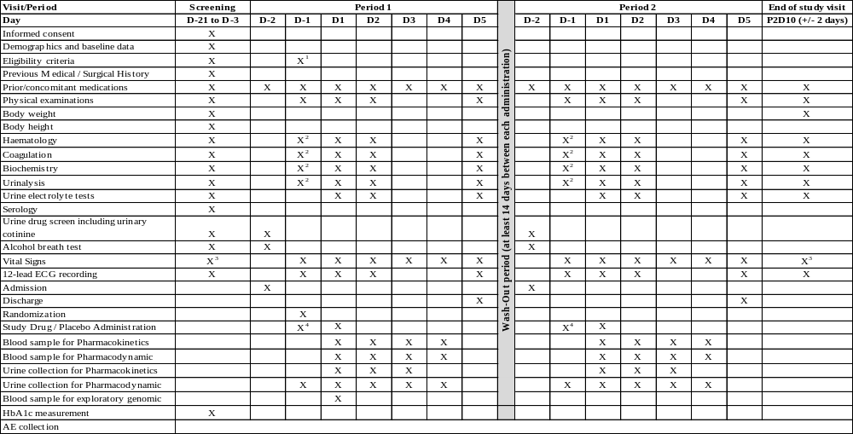

¹ Confirmation of the Inclusion/exclusion criteria prior to randomization number assignment and prior to first study product administration;
² At Pre-dose;
³ Including body temperature;
⁴ Placebo administration in blind condition for the subject.

Table 4 – Detailed flow chart for Part A – Food effect cohort
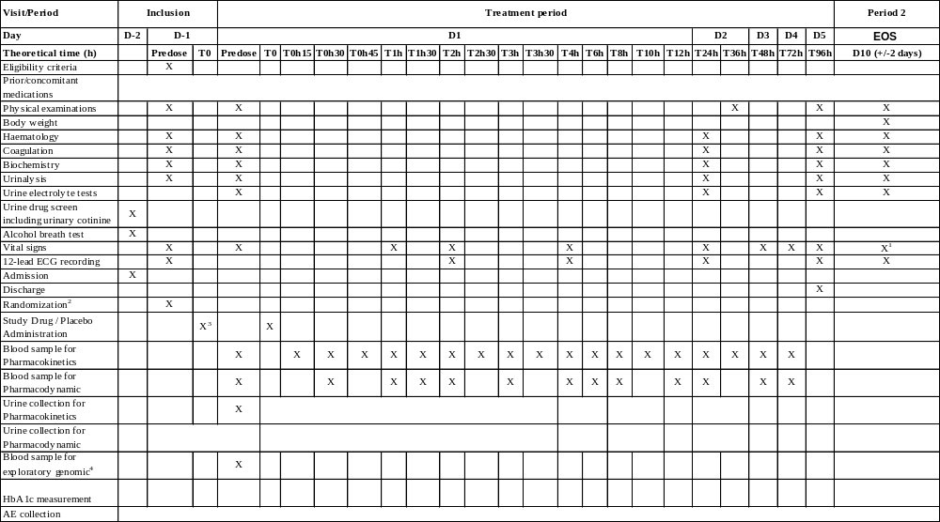
¹ Including body temperature; ² Only on P1D-1; ³ Placebo administration in blind condition for the subject; ⁴ Only on P1.
Table 5 – Study flow chart for Part B – MAD

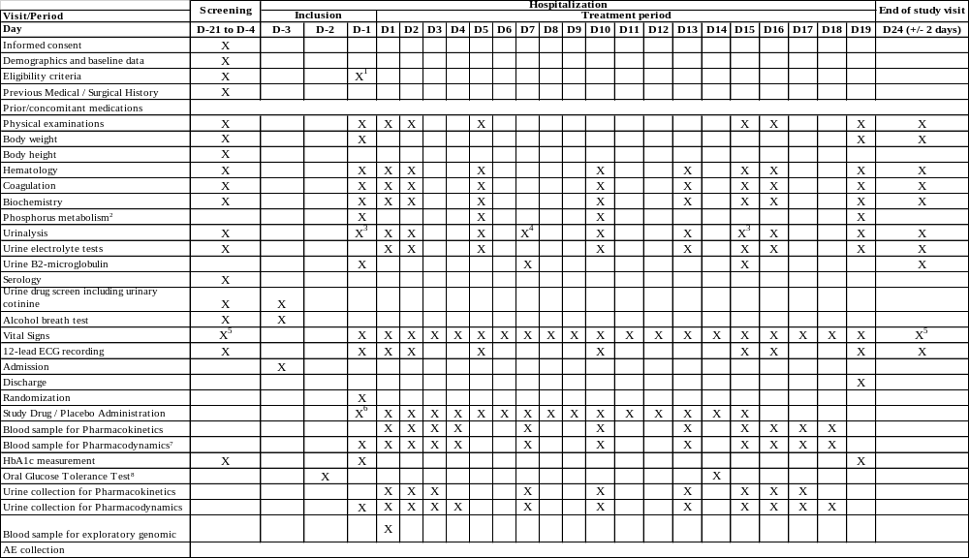

¹ Confirmation of the Inclusion/exclusion criteria prior to randomization number assignment and prior to first study product administration;
² Phosphorus metabolism: Parathyroid hormone, 25-hydroxy vitamin D, 1,25-dihydroxy vitamin D;
³ Including 24-hour urine creatinine level (T0-24h);
⁴ Only 24-hour urine creatinine level (T0-24h);⁵ Including body temperature;
⁶ Placebo administration in blind condition for the subject;
⁷ Plasma glucose measurement at predose then at T0h30, T1h, T1h30, T2h, T3h, T4h, T6h, T8h, T12h on D1, at pre-dose on D2, at pre-dose on D3, at pre-dose on D4, at pre-dose on D7, at pre-dose on D10, at pre-dose on D13, on D15 at predose and then at T0h30, T1h, T1h30, T2h, T3h, T4h, T6h, T8h, T12h administration, on D16 at T24h, on D17 at T48h and on D18 at 72h; Serum insulin measurement at predose then at T0h30, T1h, T1h30, T2h, T3h, T4h and T6h on D-1, D1 and D15 administration;
⁸ Blood sampling for OGTT at predose then at T0h30, T1h, T1h30, T2h, T3h and T4h on D-2 and D14 (after oral glucose administration).

Table 6 – Detailed flow chart for Part B – MAD (1/4)
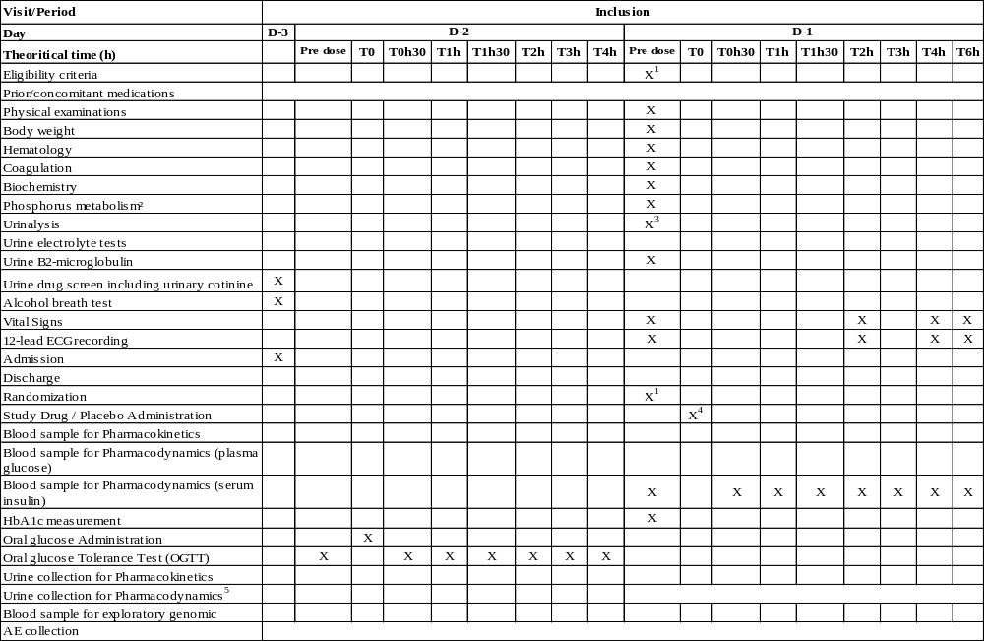
¹ Confirmation of the Inclusion/exclusion criteria prior to randomization number assignment and prior to first study product administration;
² Phosphorus metabolism (Parathyroid hormone, 25-hydroxy vitamin D, 1,25-dihydroxy vitamin D);
³ Including 24-hour urine creatinine level (T0-24h); ⁴ Placebo administration in blind condition for the subject; ⁵ Urine collection for PD from D-1 predose until D1 predose.

Table 7 – Detailed flow chart for Part B – MAD (2/4)
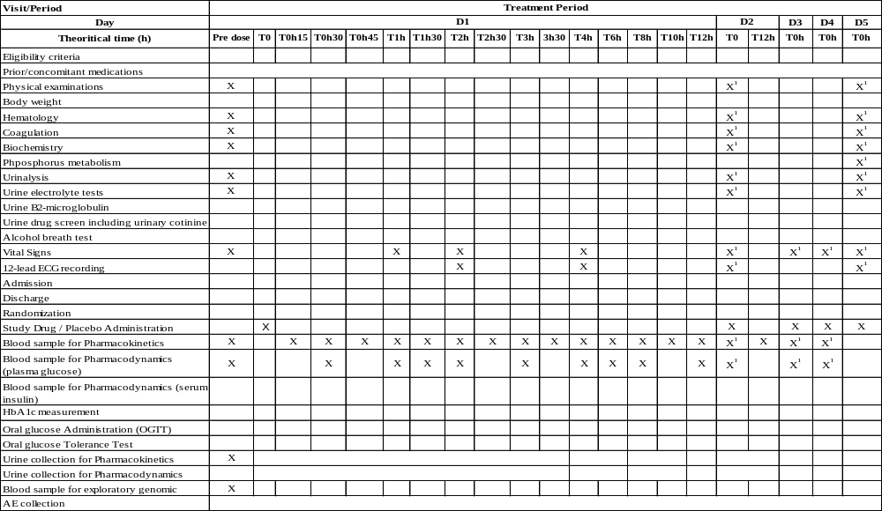

¹ At pre-dose.
Table 8 – Detailed flow chart for Part B – MAD (3/4)
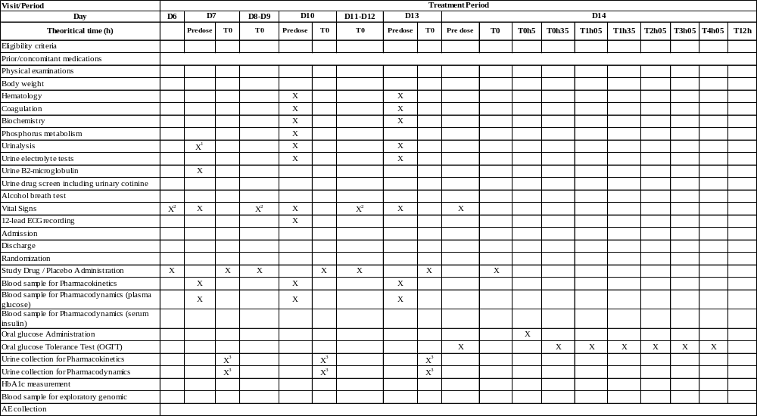

¹ Only 24-hour urine creatinine level (T0-24h);
² At Pre-dose;
³ 24 hours urine collection at D7, D10 and D13.

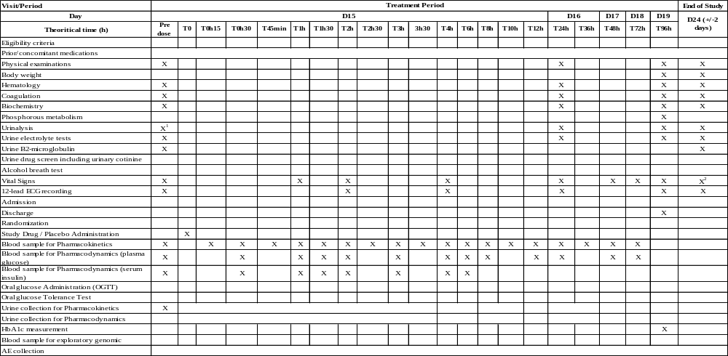Table 9 – Detailed flow chart for Part B – MAD (4/4)

¹ Including 24-hour urine creatinine level (T0-24h);
² Including body temperature.

STUDY POPULATIONS AND TREATMENTS

Randomized subjects
The randomization list will be provided by Eurofins Optimed:
- Part A – SAD: treatments will be allocated at D1;
- Part A – Food effect cohort: treatments will be allocated at D1 of each treatment period.
For each part (Part A SAD and food effect cohort), a placebo will be administered on D-1.
- Part B – MAD: treatments will be allocated from D1 to D15. A placebo will be administered on D-1.

The randomization number will be composed of 7 digits, 3 for the number of centre (specific site number in the country, starting from 001) and 4 for the inclusion number (the first digit of the inclusion number represents the cohort number). For example: 001-1001. It will be a chronological number.
A subject who prematurely end his study period after the start of the baseline period and who received treatment will be replaced.
The replacement subject will undergo the complete study. He will be given a number corresponding to the number of the subject being replaced with the suffix “-R1” (i.e. for the subject 1004, the replacement subject will receive the number 1004-R1).

Sample size
Sample size for this study was based upon empirical considerations corresponding to usual practices in this type of studies. No formal calculation was performed.

Definition of analysed populations
The following populations will be taken into account for statistical analyses:
- Intent-to-treat set (ITTS): All randomized subjects of the study will be included in this population.
- Pharmacokinetic set (PKS): Subjects from the ITTS without protocol deviations or violations thought to significantly affect the pharmacokinetic analysis will be included in this population.
- Pharmacodynamic set (PDS): Subjects from the ITTS without protocol deviations or violations thought to significantly affect the pharmacodynamic analysis will be included in this population.
- Safety set (SS): Subjects from the ITTS who will receive at least one study treatment dose will be included in this population.

Investigational treatment
The following treatments will be studied:

Name of the compound: JP-2266
Pharmaceutical form: Oral capsule (5 mg, 40 mg)
Dose per administration: Part A – SAD: 5, 15, 40, 80 and 160 mg
Part A – Food effect: 80 mg
Part B – MAD: 20, 40, 80 mg
Number of capsules: From 1 to 4 capsules
Timing for administration: Oral administrations with 200mL of tap water, in sitting position and in fasting condition for part B and in fast or fed condition for Part A (30 minutes after the beginning of the High Fat Breakfast).
Part A – SAD: Single administration on D1 at T0h around 8 a.m.
Part A – Food effect: Single administration on D1 at T0h around 8 a.m. of each period.
Part B – MAD: Repeated administrations from D1 to D15 at T0h around 8 a.m.

Name of the compound: Placebo
Pharmaceutical form: Oral capsule (5 mg, 40 mg)
Dose per administration: NA
Number of capsules: From 1 to 4 capsules
Timing for administration: Oral administrations will take place around 8 a.m. with a 200mL of tap water, in sitting position and in fasting condition for parts A and B.
Part A – SAD: Single administration on D1 at T0h around 8 a.m.
Part A – Food effect: Single administration on D1 at T0h around 8 a.m. of each period.
Part B – MAD: Repeated administrations from D1 to D15 at T0h around 8 a.m.
A single administration on D-1 morning will be also performed of the same number of capsules than in D1 morning for each subject and for all study parts (Part A for each period, Part B).

STATISTICAL ELEMENTS

General information
The analyses described in this SAP will consist of statistics for baseline characteristics, pharmacodynamics, safety and study conduct parameters. Individual data listings will also be generated. These analyses will be performed by Eurofins Optimed with SAS® statistical software (version 9.4 or higher).
Descriptive and inferential statistics on PK data will not be performed by Eurofins Optimed, then PK analyses are described in a dedicated plan.
TFLs will be generated for each study part separately. All results from the statistical analyses will be included in the Clinical Study Report (CSR).
Individual data (scheduled and recheck examinations), extracted from the database, for all included subjects, will be presented for each study part in data listings, sorted by dose group and subject.
Demographic and baseline characteristics data will be summarised by dose group and totalled over all subjects.
On-treatment data will be tabulated by dose group or regimen condition (fasted/fed for
food effect cohort of Part A (80 mg)) and time-point, unless otherwise specified.
For food effect cohort, examinations performed from D-2 to D5 of period 1 are identical to those of period 2, then period is not specified for description of the statistical analyses in section 4.
For safety parameters (laboratory, vital signs and ECG) with evaluation before the first study drug administration (D1 of each period for food effect cohort) and in case of re-checked value(s) for any subject, only the last available and reliable data will be used in statistics and estimation of other derived parameter values. After the first study drug administration, the first available and reliable value will be used (in other words, only values planned in the protocol (scheduled assessments) will be used).
Study baseline will be the last available and reliable value (unscheduled assessments taken into account) prior to the first treatment administration.
Period baseline will be the last available and reliable value (unscheduled assessments taken into account) prior to the corresponding period treatment administration.
For all parameters for which laboratory/reference ranges are available, abnormal value higher or lower than laboratory/reference ranges will be flagged (e.g. “H” or “L” respectively) and clinical assessment will be provided (normal/abnormal NCS/abnormal CS).
Emergent values will be defined as any normal values at pre-dose assessment (study or period baseline value) becoming abnormal at post-dose assessment or lower (upper) abnormal baseline value becoming upper (lower) abnormal at post-dose assessment.

Statistical methods scheduled in the protocol
All the statistical analyses presented in this SAP take into account the statistics planned in the protocol.

Imputation method
No imputation method will be used to replace missing data.

Descriptive statistics
Descriptive statistics will be performed on:
- Continuous variables using number of observations (n), number of subjects taken into account (N), mean, standard deviation (SD), standard error of the mean (SEM), minimum (Min), median and maximum (Max);
- Categorical data using frequencies (n) and percent frequencies (%).

In general, Min and Max will be quoted to the number of decimal places as recorded in the eCRF; mean, median and SD will be quoted to one further decimal place. Percentage will be rounded to one decimal place.

Inferential statistics
Safety and PD analyses will only be descriptive.
The PK/PD analysis will be descriptive and inferential (see section 4.4).

STATISTICAL ANALYSES

Status of subjects
The objective of analysis presented below is to describe the sample size of analysed populations of each study part.

Assessment / Population | Description of criteria | Statistical method
Sample size of analysed populations /  ITTS/PKS/PDS/SS | Number of included subjects within each population (yes/no) | Descriptive statistics will be presented by dose group and totalled over all subjects.
Sample size of analysed populations /  ITTS/PKS/PDS/SS | Exclusion reason of subject in case of exclusion from one population | Exclusion reasons will be listed by dose group and subject.

Baseline characteristics
The objective of analysis presented below is to describe the screening and baseline criteria for each study part.

Assessment / Population | Description of criteria | Statistical method
Demography /  ITTS/PKS/PDS/SS | Age (years)  Height (cm)  Weight (kg)  BMI (kg/m²) | Descriptive statistics will be presented by dose group and totalled over all subjects for all distinct study populations.
Medical/surgical history /  ITTS | - Number of history events  - Number and percentage of subjects with at least one medical/surgical history | Descriptive statistics will be performed by system organ class (SOC), preferred term (PT), dose group and totalled over all subjects (listing only if events ≤ 5).  Listing of history events will be reported by dose group and subject.
Previous  medication /  ITTS | - Number of medications  - Number and percentage of subjects with at least one medication | Descriptive statistics will be performed by WHO-DD terms (ATC, PT), dose group and totalled over all subjects (listing only if medications ≤ 5).  Listing of previous medications will be reported by dose group and subject.

Assessment / Population | Description of criteria | Statistical method
Serology at screening /  ITTS | Result (positive/negative) regarding anti-HIV 1 and HIV 2 antibodies, anti-HCV antibodies, HBsAg | If relevant, descriptive statistics will be performed by visit, dose group and totalled over all subjects  and/or  a listing of positive results will be displayed by dose group and subject.
Urine drug screen at screening, D-3 (Part B) or D-2 (Part A) /  ITTS | Result (positive/negative) regarding methamphetamines/amphetamines, benzodiazepines, cannabis, cocaine, opiates and barbiturates
Alcohol breath test at screening, D-3 (Part B) or D-2 (Part A) /  ITTS | Result (positive/negative)
Urinary cotinine at screening, D-3 (Part B) or D-2 (Part A) /  ITTS | Result (µg/L) | Value will be described at each visit by dose group and totalled aver all subjects.
Physical examination at screening /  ITTS | The following systems will be assessed (normal/abnormal NCS/abnormal CS):  Skin and mucous  Ears/nose/throat  Pulmonary  Cardiac  Gastro-intestinal  Neurological | If relevant, descriptive statistics on assessments will be performed by dose group and totalled over all subjects  and/or  a listing of abnormalities will be displayed by dose group and subject.

PD evaluation
Assessment / Population | Description of criteria | Statistical method
PD time-points for analysis:  - Part A/blood sample:  D1 (pre-dose, T30min, T1h, T1h30, T2h, T3h, T4h, T6h, T8h, T12h) and D2 T24h;  - Part A/urine sample:  D-1 to D2 T24h;  - In addition, for Part B/blood sample:  D-2 (OGTT from pre-dose to T4h), D-1 (serum insulin from pre-dose to T6h), D14 (OGTT from pre-dose to T4h05), D15 (plasma glucose from pre-dose to 24h and serum insulin from pre-dose to T6h);  - In addition, for Part B/urine sample:  D15 (from pre-dose to 24h);  - Weight at screening, D-1 (Part B), D19 (Part B) and EOS  - HbA1c at screening, D-1 (Part B) and D19 (Part B) /  PDS | Plasma glucose at D1 (all parts) and D15 (Part B):  - AUEC measured by trapezoidal rules from administration to T24h;  - E_{max}: maximum response from pre-dose to T24h;  - ΔE_{max}: change between maximum response and baseline value (D1 pre-dose or D15 pre-dose):  ΔE_{max} = E_{max} – baseline value  Urine glucose excretion (UGE) from administration up to 24h post-dose at D1 (all parts) and D15 (Part B):  - UGE_{24h}: Sum of post-dose urine glucose excretion values collected by time interval at D1 and D15 for Part B:  UGE_{24h} = UGE_{0-4h} + UGE_{4-8h} + UGE_{8-12h} + UGE_{12-24h}  - ΔUGE_{24h}: change from baseline in UGE for 24 hours at D1 and D15 for Part B:  ΔUGE_{24h} = D1 or D15 UGE_{24h} – UGE baseline value  where baseline value is collected from D-1 pre-dose to D1 pre-dose;  - UGE_{24h} fold increase: ratio of D1 UGE_{24h} (and D15 for Part B) on pre-existing UGE level (collected from D-1 pre-dose to D1 pre-dose).  OGTT (only for Part B at D-2 and D14 from pre-dose to T4h):  - AUEC measured by trapezoidal rules from pre-dose to T4h;  - E_{max}: maximum response from pre-dose to T4h;  - ΔE_{max}: change between maximum response and baseline value (D-2 pre-dose or D14 pre-dose (before glucose administration)):  ΔE_{max} = E_{max} – baseline value  Serum insulin (only for Part B at D-1 and D15):  - AUEC measured by trapezoidal rules from pre-dose to T6h;  - E_{max}: maximum response from pre-dose to T6h.  Body weight at screening, D-1 (Part B), D19 (Part B) and EOS:  - Change from baseline (screening for Part A or D-1 for Part B).  HbA1c:  - Value and change from baseline (D-1) to D19 (Part B). | Descriptive statistics will be performed on PD parameters by dose group or regimen condition (food effect cohort) and totalled over all subjects.

PK/PD evaluation
Assessment / Population | Description of criteria | Statistical method
PD and PK samplings at D1 (all study parts) and D15 (Part B) /  Subjects included in both population:  PKS and PDS | AUC_{0-24h}: Area under the PK plasma concentration versus time curve from drug administration to 24h measured at D1 and D15 by trapezoidal rules.  ΔUGE_{24h}: change from baseline in UGE for 24 hours at D1 and D15:  ΔUGE_{24h} = D1 or D15 UGE_{24h} – UGE baseline value  where baseline value is collected from D-1 pre-dose to D1 pre-dose | The following analyses will be performed:  - Correlation coefficient between AUC_{0-24h} and ΔUGE_{24h} at D1 and D15 separately  Before estimating the correlation coefficient (taking into account all doses) between ΔUGE_{24h} and AUC_{0-24h}, a normality test (Kolmogorov Smirnov test) will be performed on these two variables. If data are normally distributed for both variables then the Pearson correlation coefficient will be used, otherwise the Spearman correlation coefficient will be determined.  A correlation test (alpha error=5%) and a graphical representation between the two variables (scatter plot) will be carried out to highlight the correlation results at D1 and D15 (for Part B) separately.  - E_{max} model at D1 and D15 separately  The PK/PD relationship between AUC_{0-24h} and ΔUGE_{24h} (change in UGE_{24h} from D1 pre-dose) will be assessed using the E_{max} model:  ΔUGE_{24h} = E_{max} AUC_{0-24h} / (EC₅₀ + AUC_{0-24h})  where E_{max} is the maximum increase response after D1 or D15 administration (maximal UGE change-uppering effect)  and EC₅₀ is the exposure (AUC_{0-24h}) which produce 50% of E_{max}.  Parameter estimates from the model will be presented (E_{max} and EC₅₀).

Safety
The objective of analysis presented below is to evaluate the safety of the study drugs through adverse events reported during the study, laboratories and clinical parameters.

Adverse events
Assessment /  Population | Description of criteria | Statistical method
TEAEs from the first treatment administration to EOS /  SS | Number of TEAEs, number and percentage of subjects with at least one TEAE.  A TEAE will be characterised by an event that occurs for the first time, or if present before worsened during an exposure to drug(s). | Adverse events will be coded according to the Medical dictionary for regulatory activity (MedDRA).  Descriptive statistics will be performed by MedDRA codes (SOC and PT), dose group (SAD and MAD) or regimen condition (food effect cohort) and totalled over all subjects.  If TEAEs ≤ 5 then only a listing will be reported.
TEAEs from the first treatment administration to EOS /  SS | TEAE description: MedDRA terms, AE start/stop dates/times, severity, serious, relationship to study treatment, outcome, action taken with study treatment, other action, concomitant medication recorded | Listing of TEAEs will be presented by dose group (SAD and MAD) or regimen condition (food effect cohort) and subject.
NTEAEs occurred before the first treatment administration /  SS | Number of NTEAEs, number and percentage of subjects with at least one NTEAE.  A NTEAE will be characterised by an event that occurs before the study drug administration (also called “pre-dose event”). | Descriptive statistics will be performed by MedDRA codes (SOC and PT), dose group and totalled over all subjects.  If NTEAEs ≤ 5 then only a listing will be reported.
 | NTEAE description: MedDRA terms, AE start/stop dates/times, severity, serious, outcome | Listing of NTEAEs will be presented by dose group and subject.
SAE /  SS | SAE description: same variables used for TEAEs or NTEAEs. | Listing of SAEs will be presented by dose group and subject.

Laboratory
Assessment /  Population | Description of criteria | Statistical method
Laboratory test at:  - All parts:  screening, D-1, D1 pre-dose, D2, D5 and EOS  - In addition, for Part B:  D10 pre-dose, D13 pre-dose, D15 pre-dose, D16 and D19 /  SS | Biochemistry parameters:  Fasting glucose  Total protein  Creatinine  Urea  AST  ALT  Sodium  Alkaline phosphatase Potassium  GGT  Chloride  CPK  Triglycerides  Total bilirubin  Conjugated bilirubin  Unconjugated bilirubin  Total cholesterol  Lipase  Creatinine clearance  Calcium  Phosphorus  BUN  LDH  Haematology parameters:  Red blood cells  Haemoglobin  Haematocrit  MCV  MCH  MCHC  White blood cells  Neutrophils  Eosinophils  Basophils  Lymphocytes  Monocytes  Platelets  Coagulation parameters:  aPTT  Prothrombin time  INR | For each parameter, the following analyses will be performed:  - Descriptive statistics on values, position according to laboratory ranges (< range/in the range/> range) and clinical assessment (normal/abnormal NCS/abnormal CS) by dose group and totalled over all subjects at each scheduled visit (only at screening P1D-1, P1D1 pre-dose and EOS for food effect cohort);  - Change from study baseline to each scheduled post-dose visit by dose group and totalled over all subjects (only to EOS for food effect cohort);  - Listing of emergent values and their corresponding position according to laboratory ranges from study baseline by dose group and subject.  In addition, the following analyses will be performed for food effect cohort:  - Descriptive statistics on values, position according to laboratory ranges and clinical assessment by regimen condition at D-1, period baseline (D1 pre-dose), D2 and D5 of each period;  - Change from period baseline to D2 and D5 by regimen condition;  - Listing of emergent values and their corresponding position according to laboratory ranges from period baseline by regimen condition and subject.

Assessment /  Population | Description of criteria | Statistical method
Phosphorus metabolism for Part B only at D-1, D5, D10 and D19 /  SS | Parathyroid hormone  25-hydroxy vitamin D  1,25-dihydroxy vitamin D | For each parameter, the following analyses will be performed:  - Descriptive statistics on values, position according to laboratory ranges (< range/in the range/> range) and clinical assessment (normal/abnormal NCS/abnormal CS) by dose group and totalled over all subjects at each scheduled visit;  - Change from study baseline (D-1) to each scheduled post-dose visit by dose group and totalled over all subjects;  - Listing of emergent values and their corresponding position according to laboratory ranges from study baseline by dose group and subject.

Urinalysis
Assessment /  Population | Description of criteria | Statistical method
Urinalysis at:  - All parts: screening, D-1, D1 pre-dose, D2, D5 and EOS  - In addition, for Part B: D10, D13, D15, D16 and D19 /  SS | pH  Specific gravity  Glucose  Bilirubin  Ketone bodies  Occult blood  Protein  Urobilinogen  Nitrites  White blood cells  Only for Part B:  Urine creatinine level at D-1, D7, D15 | For quantitative parameter (pH and specific gravity), statistical analysis will be the same as for biochemistry (see section above).  For qualitative parameter, the following analyses will be performed:  - Descriptive statistics on qualitative values according to visit by dose group and totalled over all subjects at each scheduled visit (only at screening P1D-1, P1D1 pre-dose and EOS for food effect cohort), or by regimen condition (for food effect cohort at D-1, period baseline, D2 and D5);  - Listing of emergent values from study baseline to each post study visit by dose group and subject (only to EOS for food effect cohort) and from period baseline to D2 and D5 by regimen condition and subject for food effect cohort.
Microscopy at:  - All parts: screening, D-1, D1 pre-dose, D2, D5 and EOS  - In addition, for Part B: D10, D13, D15, D16 and D19 /  SS | Glucose  Protein  Red blood cells  White blood cells  Crystallography  Epithelial cells  Epithelial renal cells  Bacteria  Casts | Microscopy will be performed only in case of abnormalities (positive results) from urine dipstick analysis.  A listing of microscopic results (if any) will be reported by dose group, visit and subject.

Additional urine tests
Assessment /  Population | Description of criteria | Statistical method
Urine electrolyte tests at:  - All parts: screening, D1 pre-dose, D2, D5 and EOS  - In addition for Part B: D10, D13, D15, D16 and D19 /  SS | Sodium  Potassium  Chloride  Calcium  Phosphorus | For each parameter, the following analyses will be performed:  - Descriptive statistics on values, position according to reference ranges (< range/in the range/> range) and clinical assessment (normal/abnormal NCS/abnormal CS) by dose group and totalled over all subjects at each scheduled visit (only at screening P1D-1, P1D1 pre-dose and EOS for food effect cohort);  - Change from study baseline to each scheduled post-dose visit by dose group and totalled over all subjects (only to EOS for food effect cohort);  - Listing of emergent values and their corresponding position according to laboratory ranges from study baseline by dose group and subject.  In addition, the following analyses will be performed for food effect cohort:  - Descriptive statistics on values, position according to laboratory ranges and clinical assessment by regimen condition at D-1, period baseline (D1 pre-dose), D2 and D5 of each period;  - Change from period baseline to D2 and D5 by regimen condition;  - Listing of emergent values and their corresponding position according to laboratory ranges from period baseline by regimen condition and subject.
Urine  β2-microglobulin for Part B at D-1, D7, D15 and EOS /  SS | β2-microglobulin | The following analyses will be performed:  - Descriptive statistics on value, position according to reference range (< range/in the range/> range) and clinical assessment (normal/abnormal NCS/abnormal CS) by dose group and totalled over all subjects at each scheduled visit;  - Change from study baseline (D-1) to each scheduled post-dose visit by dose group and totalled over all subjects;  - Listing of emergent values and their corresponding position according to laboratory ranges from study baseline by dose group and subject.

Clinical criteria
Assessment /  Population | Description of criteria | Statistical method
Vital signs at:  - All parts: screening, D-1 pre-dose, D1 (pre-dose, T1h, T2h and T4h), D2, D3, D4, D5 and EOS;  - In addition, for Part B: D-1 (T2h, T4h and T6h), from D6 to D14 pre-dose, D15 (pre-dose, T1h, T2h and T4h), from D16 to D19 /  SS | Supine and standing SBP  Supine and standing DBP  Supine and standing HR  Conclusion (normal/abnormal NCS/abnormal CS)  At screening and EOS: Oral temperature  Conclusion (normal/abnormal NCS/abnormal CS) | The following analyses will be performed:  - Descriptive statistics on values, position according to available reference ranges (< range/in the range/> range) according to daytime point by dose group and totalled over all subjects (only at screening P1D-1, P1D1 pre-dose and EOS for food effect cohort);  - Change from study baseline (D1 pre-dose or screening for temperature) to each post-dose daytime point by dose group and totalled over all subjects (only to EOS for food effect cohort);  - Listing of emergent values and their corresponding position according to reference ranges from study baseline by dose group and subject.  - For vital signs: Listing of orthostatic hypotension (supine SBP (DBP) – standing SBP (DBP) ≥ 20 mmHg) by dose group, daytime point and subject;  - Description of conclusion by daytime point, dose group and totalled over all subjects;  - Listing of abnormal conclusions by dose group and subject.  In addition, the following analyses will be performed for food effect cohort:  - Descriptive statistics on values, position according to available reference ranges by regimen condition at D-1, period baseline (D1 pre-dose), D2, D3, D4 and D5 of each period;  - Change from period baseline to D2, D3, D4 and D5 by regimen condition;  - Listing of emergent values and their corresponding position according to reference ranges from period baseline by regimen condition and subject;  - Description of conclusion by daytime point, regimen condition and totalled over all subjects;  - Listing of abnormal conclusions by regimen condition and subject.
12-lead ECG at:  - All parts: screening, D-1 pre-dose, D1 (T2h and T4h), D2, D5 and EOS;  - In addition, for Part B: D-1 (T2h, T4h and T6h), D10, D15 (pre-dose, T2h and T4h), D16 and D19 /  SS | HR  PR  QRS  QT  QTcF  Conclusion (normal/abnormal NCS/abnormal CS)
Assessment /  Population | Description of criteria | Statistical method
Physical examination at:  - All parts:  D-1, D1, D2, D5 and EOS;  - In addition, for Part B:  D15, D16 and D19 /  SS | Result (normal/abnormal NCS/abnormal CS) | Results will be statistically described by visit, dose group and totalled over all subjects  and/or  A listing of abnormalities will be displayed by dose group, daytime point and subject.

Exploratory analysis
Assessment /  Population | Description of criteria | Statistical method
Exploratory analysis for both study parts /  ITTS | - JP-2266 metabolites in human blood and urine from the PK evaluation  - Genes involved in JP-2266 absorption and metabolism | Exploratory parameters will be statistically described by dose group (or condition group for food effect part) and totalled over all subjects for each study part.  If relevant drug metabolites are detected, the correlation between pharmacokinetic parameters, including metabolite-to-parent drug exposure ratios, and pharmacokinetics/pharmacodynamics can be evaluated.  If inter-individual pharmacokinetics results differences are observed, genotyping analysis could be performed to assess the correlation between genetic polymorphism and pharmacokinetic parameters.

Study conduct
The objective of analysis presented below is to describe the parameters of the study conduct.

Assessment /  Population | Description of criteria | Statistical method
Study duration /  ITTS/PKS/PDS/SS | Study duration = Study end date – screening date + 1 (days) | Descriptive statistics will be performed by dose group and totalled over all subject.
Withdrawn subjects during study /  ITTS | - Number of subjects having successfully completed the study  - Reason for withdrawal | Descriptive statistics will be performed on subject number by dose group and totalled over all subject.  Listing of reasons (if any) will be displayed by dose group and subject.
Concomitant medications:  - Starting after the first treatment administration;  - Starting prior to the first treatment administration /  ITTS | - Number of occurrences of concomitant medications  - Number and percentage of subjects taking at least one concomitant medication | Concomitant medications will be coded according to the WHO-DD.  Descriptive statistics will be performed by WHO-DD terms (ATC and PT), dose group and totalled over all subjects (listing only if medications ≤ 5).  Listing of medications will be presented by dose group and subject.

INDIVIDUAL DATA
Individual data listings, including unscheduled evaluations, will be presented by dose group, randomisation number and time point for the following parameters evaluated from screening to end of study:

- Discontinued subjects
Discontinued subjects
Reason

- Subjects excluded from the study populations
Subjects excluded
Reason

- Randomization
Was the subject randomized? (yes/no)
Date of randomization
Food effect cohort (yes/no)

- Eligibility of subject
Are all the inclusion criteria answered Yes? (yes/no)
If no, inclusion criteria numbers answered as No
Comment
Are all the non-inclusion criteria answered No? (yes/no)
If no, non-inclusion criteria numbers answered as Yes
Comment
Is the subject eligible to participate to the study? (yes/no)
Date of confirmation of eligibility
Comments on eligibility/non-eligibility

- Dates of visits
Date of visit

- Populations of the study
Subject in intent-to-treat set (yes/no)
Subject in pharmacokinetic set (yes/no)
Subject in pharmacodynamic set (yes/no)
Subject in safety set (yes/no)

- Informed consent and demography
Age
Height (cm)
Weight (kg)
BMI (kg/m²)
Has the nature of the study been explained to the subject and written informed consent has been obtained? (yes/no) and date of signed informed consent
Has the written exploratory genomic informed consent has been obtained? (yes/no) and date of signed informed consent

- Medical and surgical history
Medical/surgical history
MedDRA codes
Start/stop date
Ongoing (yes/no)

- Physical examination at screening
Parameter name (skin and mucous/ears, nose, throat/pulmonary/cardiac/gastro-intestinal/neurological)
Assessment (normal/abnormal)
Abnormal finding
Clinically significant (yes/no)

- Serology
Sample collected? (yes/no)
Date of collection
Anti-HIV 1 and 2 antibodies (positive/negative)
Anti-HCV antibodies (positive/negative)
HBsAg (positive/negative)
Comments

- Urine drug screen
Visit
Sample collected? (yes/no)
Date of collection
Result (positive/negative)
If positive: positive drug

- Alcohol breath test
Visit
Test performed? (yes/no)
Date performed
Result (positive/negative)
Comments

- Urinary cotinine
Visit
Sample collected? (yes/no)
Date of collection
Result (µg/L)
Comments

- Prior/concomitant medication
Medication number
Taken prior to study? (yes/no)
Medication name
WHO-DD terms
Indication
Start/end date
Ongoing (yes/no)
Dose
Unit
Route
Frequency
AE number (if the concomitant medication is given for an AE)

- Placebo administration
Date and time of placebo administration
Administered dose (mg)
Has the placebo administration been performed according to the protocol? (yes/no)
If no: comment

- Drug administration
Date and time of study drug administration
Administration dose (mg)
Has the drug administration been performed according to the protocol? (yes/no)
If no: comment

- Blood sample for PK
Visit
Time point
Sample collected? (yes/no)
Scheduled date and time
Actual date and time
Meal restriction respected? (yes/no/unknown)
Comment

- Blood sample for PD
Visit
Time point
Sample collected? (yes/no)
Scheduled date and time
Actual date and time
Comment

- Urine sample for PK and PD
Visit
Time internal
Sample collected? (yes/no)
Start/end date/time
Urine volume (g and mL)
Comment

- PK and PD results
Visit
Available PK parameters
Plasma glucose
Urine glucose excretion
OGTT
Serum insulin
Body weight
HbA1c
Comments

- Adverse events
Adverse event number
MedDRA terms
Start/end date/time
Severity (mild/ moderate/ severe)
Serious (yes/no)
Congenital anomaly or birth defect (yes/no)
Significant disability (yes/no)
Death (yes/no)
Life threatening (yes/no)
Other medically important event (yes/no)
Hospitalization prolonged (yes/no)
Date of hospitalization
Relationship to study treatment (probable/possible/unlikely/unrelated/not assessable)
Outcome (recovered/resolved, recovering/resolving, recovered/resolved with sequelae, not recovered/not resolved, fatal, unknown)
Action taken with study treatment (dose not changed/drug interrupted/drug withdrawn/not applicable/unknown)
Other action (yes/no) and if yes: specify
Any relevant concomitant medication recorded? (yes/no)

- Biochemistry
Visit
Sample collected? (yes/no) If no: specify
Fasting state (yes/no/unknown)
Date and time of collection
Result, unit, laboratory ranges (LLN/ULN) and clinical assessment (normal/abnormal NCS/abnormal CS/not done) for the following criteria:
Fasting glucose
Total protein
Creatinine
Urea
AST
ALT
Sodium
Alkaline phosphatase
Potassium
GGT
Chloride
CPK
Triglycerides
Total bilirubin
Conjugated bilirubin
Unconjugated bilirubin
Total cholesterol
Lipase
Creatinine clearance
Calcium
Phosphorus
BUN
LDH
Comments

- Haematology
Visit
Sample collected? (yes/no) If no: specify
Date and time of collection
Result, unit, laboratory ranges (LLN/ULN) and clinical assessment (normal/abnormal NCS/abnormal CS/not done) for the following criteria:
Red blood cells
Haemoglobin
Haematocrit
MCV
MCH
MCHC
White blood cells
Neutrophils
Eosinophils
Basophils
Lymphocytes
Monocytes
Platelet
Comments

- Coagulation
Visit
Sample collected? (yes/no) If no: specify
Date and time of collection
Result, unit, laboratory ranges (LLN/ULN) and clinical assessment (normal/abnormal NCS/abnormal CS/not done) for the following criteria:
aPTT
Prothrombin time
INR
Comments

- Urinalysis
Visit
Sample collected? (yes/no) If no: specify
Date and time of collection
Result, available normal ranges (LLN/ULN) and clinical assessment (normal/abnormal NCS/abnormal CS/not done) for the following criteria:
pH
Specific gravity
Glucose
Protein
Ketone bodies
Occult blood
Bilirubin
Urobilinogen
Nitrites
White blood cells
Comments

- Microscopy (only in case of pathological finding with urine dipstick analyses)
Visit
Result, available unit, available normal ranges (LLN/ULN) and clinical assessment (normal/abnormal NCS/abnormal CS/not done) for the following criteria:
Glucose
Protein
Red blood cells
White blood cells
Epithelial cells
Epithelial renal cells
Bacteria
Casts
Crystallography
Comments

- Urine electrolyte tests
Visit
Result, available unit, available normal ranges (LLN/ULN) and clinical assessment (normal/abnormal NCS/abnormal CS/not done) for the following criteria:
Sodium
Potassium
Chloride
Calcium
Phosphorus
Comments

- Vital signs
Visit
Vital signs collected? (yes/no) If no: specify
Date of measurement
Body temperature (°C), Result (normal/abnormal), Clinically significant (yes/no)
Position (supine/standing)
Actual time position
Actual time measurement
SBP (mmHg)
DBP (mmHg)
HR (bpm)
Result (normal/abnormal)
Clinically significant (yes/no)
Abnormal finding/relevant comments

- Physical examination during the study
Visit
Time point
Did the physical examination performed? (yes/no) If no: specify
Date/time performed
Result (positive/negative)
Abnormal physical finding
Clinically significant? (yes/no)

- 12-lead ECG
Visit
ECG performed? (yes/no) If no: specify
Date and time of ECG
HR (bpm)
PR (ms)
QRS (ms)
QT (ms)
QTcF (ms)
Conclusion result (normal/abnormal)
Clinically significant? (yes/no)
Abnormality finding/Relevant comment

- Study duration
Duration (days)

- Meals
Visit
Meals date
Meal taken: breakfast/lunch/dinner (yes/no)
Meal start/end time
Comment

- Blood sample for exploratory genomic
Visit
Time point
Sample collected? (yes/no)
Actual date and time
Comment

- Study restriction
Did the subject respect the study restrictions throughout the course of the study? (yes/no) and if no: clarify

- Study completion
Completion/discontinuation date
Status (completed/AE/lost to follow-up/withdrawal by subject/physician decision/death/protocol violation/study terminated by sponsor/other)
If other: specify

- Study comments
Comment

APPENDIX: Normal Ranges

Vital signs: reference ranges

Criterion (unit) | Reference range
Supine SBP (mmHg) | [95-140]
Supine DBP (mmHg) | [50-90]
Supine HR (bpm) | [45-90]
Temperature (°C) | ]36.0-37.6[

ECG: reference ranges

Criterion (unit) | Reference range
PR (ms) | ]120-210[
QRS (ms) | [0-120[
QTcF (ms) | [0-430]

